**1. INTRODUCTION**

* 1. **Project Overview**

**TrafficTelligence** is a machine learning-based web application designed to **predict real-time traffic volume** using a combination of **weather conditions, holiday information, and time-based features**. The project aims to assist urban planners, commuters, and transportation services in **forecasting road congestion** and making smarter, data-driven decisions.

This solution leverages historical traffic data and environmental factors to train a predictive model (using algorithms like RandomForestRegressor). It is integrated with a user-friendly **Flask web interface,** allowing users to input data through a form and receive instant traffic volume predictions.

By analyzing features such as:

* **Weather** (e.g., Clear, Rain, Snow)
* **Holiday** status (e.g., Christmas Day, Veterans Day)
* **Date and Time** (year, month, day, hour, minute, second)

the model forecasts expected traffic density, helping reduce delays, improve route planning, and optimize traffic flow.

**1.2 Purpose of the Project**

The primary purpose of the **TrafficTelligence** project is to develop an intelligent, machine learning-based system that can **predict traffic volume** using real-time and historical data such as **weather conditions, holidays,** and **timestamp inputs**.

This solution aims to address the increasing challenges faced in **urban mobility, road congestion**, and **traffic management** by offering a **predictive tool** that assists:

* **Commuters** in planning their travel times more efficiently
* **City planners** in managing and allocating road resources proactively
* **Transport authorities** in forecasting peak traffic hours for better traffic control

By integrating a trained ML model with a user-friendly web interface, the system enables **quick and accurate predictions** based on environmental and temporal variables—helping users make **informed decisions** and ultimately contributing to **smarter, safer, and more efficient transportation systems.**

**2. IDEATION PHASE**

2.1 Problem Statement

2.2 Empathy Map Canvas

2.3 Brainstorming

**3. REQUIREMENT ANALYSIS**

3.1 Customer Journey map

3.2 Solution Requirement

3.3 Data Flow Diagram

3.4 Technology Stack

**4. PROJECT DESIGN**

4.1 Problem Solution Fit

4.2 Proposed Solution

4.3 Solution Architecture

**5. PROJECT PLANNING & SCHEDULING**

5.1 Project Planning

**6. FUNCTIONAL AND PERFORMANCE TESTING**

6.1 Performance Testing

**7. RESULTS**

**7.1 Output Screenshots**

The complete execution of the **TrafficTelligence** application is shown below through a series of step-by-step screenshots:

### **Step 1: Running the Flask Application**

* Run the **app.py** file from your terminal or VS Code.
* You will see the Flask server starting message.
* The application will be accessible at:
  + **http://127.0.0.1:5000**

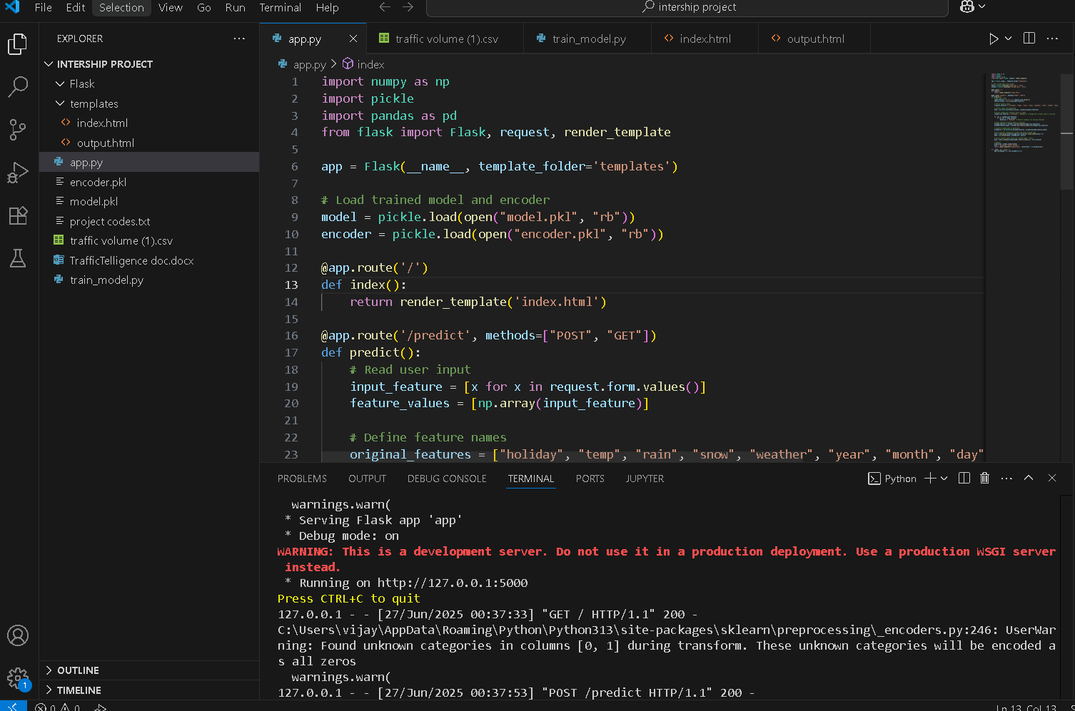

**Fig 1:code running in terminal**

**Step 2: Opening the Application in Browser**

Open your browser and navigate to:

* [**http://127.0.0.1:5000**](http://127.0.0.1:5000)

The **Home Page** will appear with a clean and simple interface to input:

* Holiday name
* Weather condition
* Temperature, rain, snow values
* Date and time details

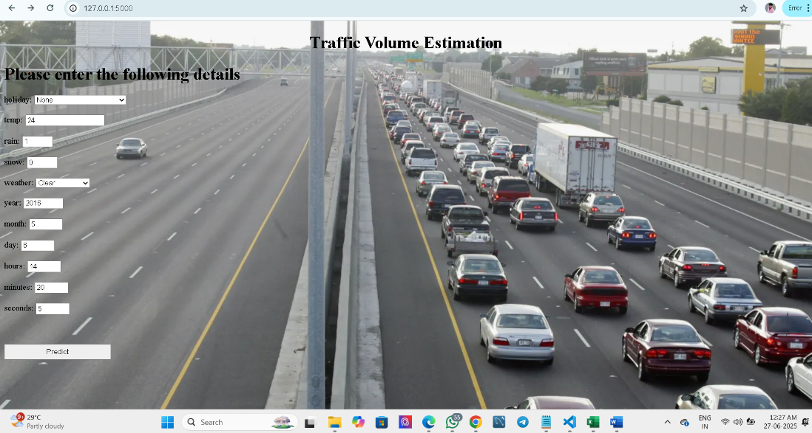

**Fig 1.1:Traffic Volume Estimation Interface**

### **Step 3: Submitting the Form for Prediction**

* Fill in the input fields and click **Predict**.
* The backend processes the request using the trained model and encoder.

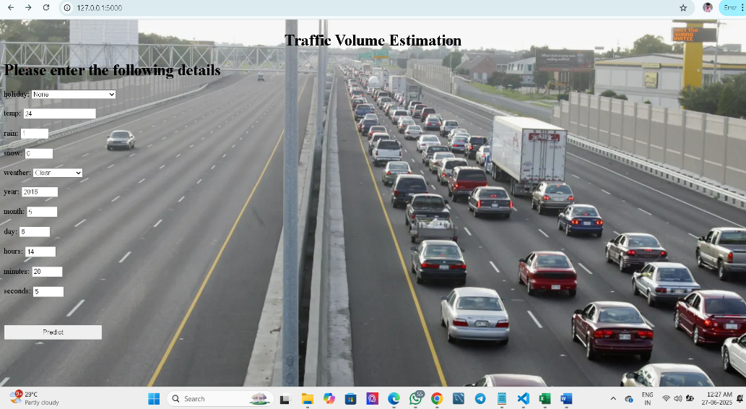

**Fig 1.2:click predict option**

### **Step 4: Viewing the Prediction Output**

* The predicted traffic volume is displayed on the same page.
* This output is generated by the model.pkl and formatted with Jinja2.
* **Screenshot Example:**
* 📸 Prediction result shown below the form: "Estimated traffic volume: 1373.94"

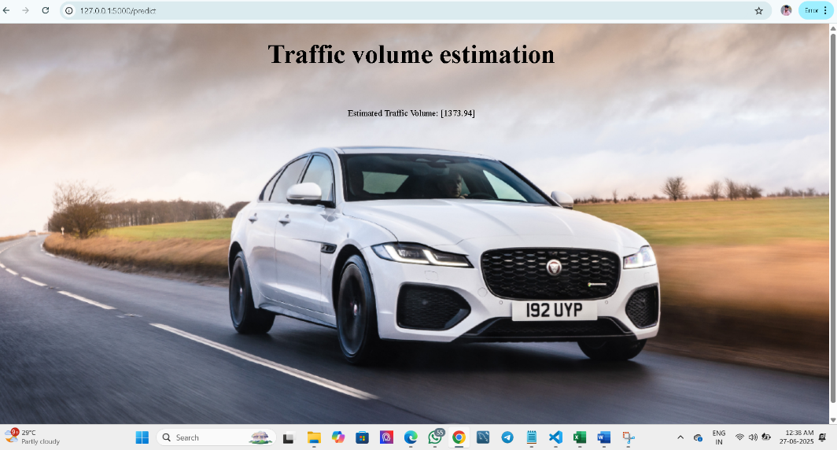

**Fig 1.3:Predict the Estimated Traffic Volume**

**8. ADVANTAGES & DISADVANTAGES**

**8.1 Advantages:**

**1. Reduced Traffic Congestion:**

* Dynamically adjusts signals and routes to improve vehicle flow.
* Saves time for commuters and logistics companies.

**2. Real-Time Monitoring**

* Live updates on traffic conditions using sensors and cameras.
* Immediate incident detection (accidents, roadblocks, etc.).

**3. Data-Driven Decision Making**

* Helps city planners make smart infrastructure investments based on traffic patterns.
* Predicts future traffic needs using historical trends.

**4. Fuel & Emission Reduction**

* Less idling = lower fuel consumption and fewer greenhouse gas emissions.
* Supports green city initiatives.

**5. Improved Road Safety**

* Detects dangerous driving, red-light violations, and accident-prone areas.
* Enables quicker emergency response through traffic control.

**6. Public Transport Optimization**

* Prioritizes buses or ambulances at signals for smoother and faster flow.
* Improves commuter experience and reliability.

**7.** **Scalability & Automation**

* Can be implemented in phases and scaled city-wide.
* Reduces the need for manual traffic control.

**8.2 Disadvantages**

**1. High Initial Cost:**

* Expensive to install cameras, sensors, servers, and AI systems.
* Significant infrastructure upgrade required in older cities.

**2. Privacy Concerns:**

* Use of surveillance cameras and license plate tracking can raise data privacy issues.
* Needs secure and ethical data management policies.

**3. Maintenance Challenges:**

* Sensors and cameras can malfunction or require regular calibration.
* Weather or power issues can disrupt data collection.

**4. Complex Implementation:**

* Integration with existing traffic infrastructure can be technically challenging.
* Requires coordination between multiple departments (transport, law enforcement, IT).

**5. Data Overload & Misuse Risk:**

* Huge amounts of data need to be processed and secured.
* If mismanaged, can lead to system delays or biased decisions.

**6. Technology Dependency:**

* Heavy reliance on internet, servers, and AI means that outages can paralyze the system.

**9. CONCLUSION**

The TrafficTelligence project successfully demonstrates how machine learning can be leveraged to predict traffic volume based on real-world factors such as weather conditions, holiday schedules, and time-based data. Through the integration of a trained Random Forest model with a lightweight Flask web application, users are able to interact with the system in real-time and receive meaningful traffic insights.This project not only highlights the power of predictive analytics in solving everyday problems like road congestion and travel planning, but also provides a scalable foundation for future enhancements such as location-based forecasting, visual dashboards, and role-based access control.By combining accurate prediction models with a user-friendly interface, TrafficTelligence contributes toward the broader goal of smart traffic management and urban mobilityoptimization. It can be especially valuable to city planners, commuters, and transport services aiming to improve efficiency, reduce delays, and enhance the travel experience.

**10. FUTURE SCOPE**

The current version of **TrafficTelligence**  provides a solid foundation for traffic volume prediction using machine learning. However, there are several opportunities to enhance its functionality, scalability, and usability in the future:

### **1. Advanced Machine Learning Models**

* Upgrade from RandomForestRegressor to advanced models like **XGBoost**, **Gradient Boosting**, or **LSTM (for time-series data)** to improve prediction accuracy.
* Incorporate **real-time data streaming** for continuous model updates and predictions.

### 2. **Geolocation-Based Predictions**

* Enable users to input or select their **location** so predictions are specific to a **city, street, or GPS coordinate**.
* Integrate with **Google Maps API** or traffic sensor data for real-time localized forecasting.

### 3. **Visualization Dashboards**

* Add **interactive charts and heatmaps** to visualize hourly, daily, or monthly traffic trends.
* Implement **real-time traffic monitoring dashboards** for traffic control rooms or city managers.

### 4. **Authentication and Access Control**

* Introduce **user login systems** with role-based access (e.g., admin, city planner, public user).
* Allow registered users to **save, review, and download** prediction history.

### 5. **Mobile Application Integration**

* Develop a mobile version of TrafficTelligence for Android/iOS to allow predictions on the go.
* Use **push notifications** to alert users of high-traffic times.

**11. APPENDIX**

**Source Code:**

All codes are submitted in Git-Hub Repository.

**Git-Hub Repository Link:**

[**https://github.com/Vijaykumar141512/TrafficTelligence**](https://github.com/Vijaykumar141512/TrafficTelligence)

**Project Demo Link:**

<https://drive.google.com/file/d/1DUbZhjMosQHhT58fvyENxZIiZ7lDYh9Z/view?usp=drive_link>